H.T No
Regulations:
A15

Sreenidhi Institute of Science and Technology
(An Autonomous Institution)
Code No: 5FC05 Date: 10-Oct-2020 (AN)

B.Tech IV-Year I-Semester External Examination, October - 2020 (Supplementary)
Data Warehousing and Data Mining (CSE)

Time: 2 Hours Max.Marks:75

Note: a) No additional answer sheets will be provided.
b) All sub-parts of a question must be answered at one place only, otherwise it will not be valued.
c) Missing data can be assumed suitably.

ANSWER ANY 5 OUT OF 8 QUESTIONS. EACH QUESTION CARRIES 15 MARKS.

1. | a) | What is Data Mining? How the data mining systems are classified? | [8M]
 | b) | What is Data Pre-Processing? Explain the different phases in data transformation. | [7M]
2. | a) | Differentiate OLTP and OLAP. | [8M]
 | b) | Demonstrate Star and Snowflake schemas for conceptual modeling of a warehouse. | [7M]
3. | a) | Discuss about Attribute Relevance Analysis. | [8M]
 | b) | How to mine descriptive statistical measures in large databases. Explain in detail. | [7M]
4. | a) | Apply Apriori algorithm to find out the frequent items from the given database.  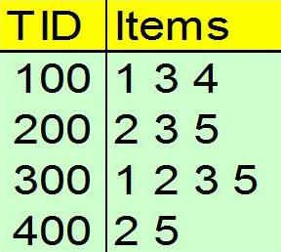 | [8M]
 | b) | Explain in detail about multi-dimensional associations | [7M]
5. | a) | What is Classification? Explain its two phases. | [8M]
 | b) | Explain in detail about Bayesian Classification approach. | [7M]
6. | a) | What is Clustering? How data can be represented in a cluster. | [8M]
 | b) | Explain in detail about DBSCAN algorithm. | [7M]
7. | a) | Discuss about various types of concept hierarchies. | [8M]
 | b) | Explain the steps involved in Attribute Oriented Induction. | [7M]
8. | a) | How Association, Classification and Clustering are useful for data analysis? | [8M]
 | b) | Explain the various methods of Outlier detection. | [7M]

-- 00 -- 00 –

